**Name: ____________________________________ Id: ______________**

1. Determine the representation of (47 )10 using the following code 5421 (1)

|  |
| --- |
|  |
|  |
|  |
|  |

1. Add the following two BCD numbers, (1000 0011 1001) + (0011 0110 0011) (3)

|  |
| --- |
|  |
|  |
|  |
|  |
|  |
|  |
|  |
|  |
|  |

1. Calculate the propagation delay of the following logic diagram (1)

Knowing the propagation delay of the following gates: NOT gate=3nsec AND gate & OR gate=10 nsec NAND gate & NOR gate=13 nsec XOR gate=20nsec XNOR gate=23 nsec

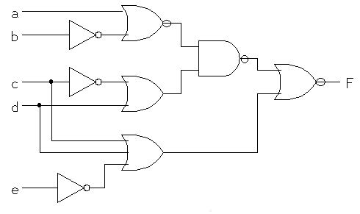

1. Draw the logic diagram for the following function after simplification using k-map,

F(A,B,C,D)= π(2,6,9,11,13,15)+d(1,5,10,14) as SoP (5)

|  |
| --- |
|  |
|  |
|  |
|  |
|  |
|  |
|  |
|  |
|  |

|  |
| --- |
|  |
|  |
|  |
|  |
|  |
|  |
|  |
|  |
|  |

|  |
| --- |
|  |
|  |
|  |
|  |
|  |
|  |
|  |
|  |
|  |
|  |
|  |
|  |